Temasek Polytechnic
School of Informatics and IT

Diploma in Information Technology (IT)

Software Design Specifications (DS)

Project Particulars

Tutor | Mr Qi Yutao
Class | P01
Project Title | Delonix Regia Hotel Management System

Project Team’s Particulars

Matric Number | Student Name
1303140F | Jaelyn Lim Hui Wen
1304174D | Leong Min En
1303084F | Loh Shi Jia, Serene
1306932C | Reyner Leong

Revision History

Date | Version | Description | Author
11/05/15 | 1.0 | Draft 1 for Architecture Design | Jaelyn Lim Hui Wen & Reyner Leong
11/05/15 | 1.1 | Draft 1 for User Interface (UI) Design | Leong Min En
11/05/15 | 1.2 | Draft 1 for Program Design | Loh Shi Jia, Serene
14/05/15 | 2.0 | Draft 1 for Database Design | Jaelyn Lim Hui Wen
17/05/15 | 3.0 | Updated Architecture Desgin & Database Design | Jaelyn Lim Hui Wen
17/05/15 | 3.1 | Updated User Interface (UI) Design | Leong Min En
17/05/17 | 3.2 | Updated Program Design | Loh Shi Jia, Serene

Table of Contents

1. DISTRIBUTION OF WORKLOAD 4
2. ARCHITECTURE DESIGN 5
3. USER INTERFACE (UI) DESIGN 9
4. PROGRAM DESIGN 10
5. DATABASE DESIGN 28

DISTRIBUTION OF WORKLOAD
Design | Members
Architecture Design | Jaelyn Lim Hui Wen & Reyner Leong
User Interface (UI) Design | Leong Min En
Program Design | Loh Shi Jia, Serene
Database Design | Jaelyn Lim Hui Wen

ARCHITECTURE DESIGN
The system architecture design of Delonix Regia Hotel Management System is based on the three-tier client server architecture which consist of a presentation tier, a business logic tier and a data access tier.
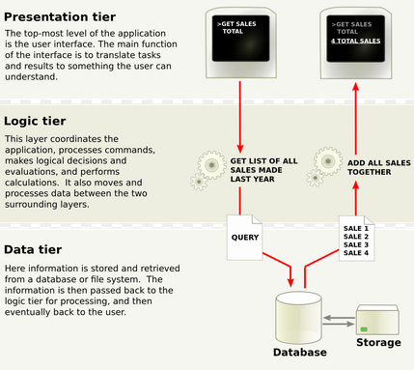
Figure 1: 3-Tier Architecture

In a three-tier architecture, the functional process logic, data access, computer data storage and user interface are developed and maintained as independent modules on separate platforms. It allows any one of the three tiers to be upgraded or replaced independently.
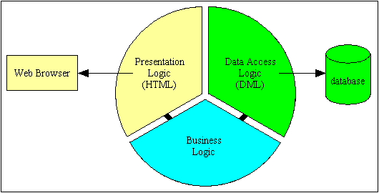
Figure 2: 3-Tier Architecture
- Presentation Tier
The presentation tier is the top most layer of the Hotel Management System. It can receive requests from and return responses to an outside agent such as another piece of software. It can also send requests to and receive responses from the business tier. However it does not have direct access to the database or the data access tier.
For the proposed hotel management system, the presentation tier is mainly responsible for the user interface of the system which deals with the display of information related to services such as checking the room availability or making a reservation for rooms. The presentation tier of the Hotel Management System is mainly created with ASP .NET Web Application in C# using Visual Studio 2012.
- Business Logic Tier
The business logic tier is the middle tier of the three-tier architecture. It can receive requests from and return response to the presentation tier. It can also send requests to and receive responses from the data access tier. However, it cannot access the database in the data access tier directly.
For the proposed hotel management system, the business logic such as the data required would be defined in this tier. This tier is responsible for the information exchange between the user interface and the database of the system. The system mainly consist of the users, which can be further classified into the customers, hotel owners, staff and system administrator of the Hotel.
- Data Access Tier
The database tier is the final and last tier of the three-tier architecture. It can only send requests to and receive responses from the business logic tier Requests could not be issued to anything other than the database management system which it supports.
The database server of the Delonix Regia Hotel Management System is located in this tier and all the information that the system required are stored and retrieved from here. Microsoft SQL Server 2012 will be used to create the database of the system for this proposed hotel management system.
Advantages of 3-Tier Architecture | Disadvantages of 3-Tier Architecture
Scalability:  - Can be deployed on many machines.  - Database does not requires a connection from every client  Reusability:  - The specific language of implementation of the middle tier can be made transparent if an standard object is employed  Improve Data Integrity:  - Middle tier ensure that only valid data is allowed to be updated in the database  Improved Security:  - Data layer is more secure as client does not have direct access to the database  - Business logic is more secure as it is placed on a more secure central server  Reduced Distribution:  - Changes to business logic only need to be updated on the application servers and does not have to be distributed to all the clients  Improved Availability  - Mission-critical applications can make use of redundant application servers and redundant database servers, so it can recover from network or server failures | More complexity/effort  - Point of communication are doubled

- USER INTERFACE (UI) DESIGN 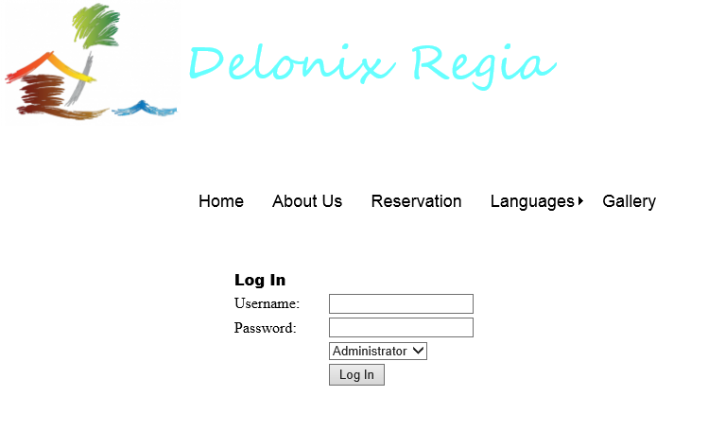
- Consistency. The most important thing is to ensure user interface works with consistently. Put your buttons in consistent places on all your windows, use the same wording in labels and messages, and use a consistent color scheme throughout. Consistency in user interface enables users to build an accurate mental model of the way it works, and accurate mental models lead to lower training and support costs.
- Group things effectively. Items that are logically connected should be grouped together on the screen to communicate they are connected, whereas items that have nothing to do with each other should be separated. Use white space between collections of items to group them and/or you can put boxes around them to accomplish the same thing.
- Be purposeful in page layout. Consider the spatial relationships between items on the page and structure the page based on importance. Careful placement of items can help draw attention to the most important pieces of information and can aid scanning and readability.
- Strategically use color and texture. Direct attention toward or redirect attention away from items using color, light, contrast, and texture to your advantage.

PROGRAM DESIGN
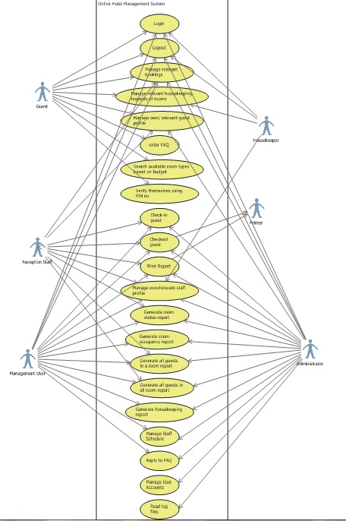
Login
Description: This use case allows users to login into the HMS system.
Logout
Description: This use case allows users to logout of the HMS system.
Manage relevant bookings
Description: This use case enables guests to manage (add new bookings, modify current booking, delete current booking or view their booking) their own bookings and allows for the hotel staff to manage the guests’ bookings as well.
Manage relevant housekeeping requests of rooms
Description: This use case enables guests to make special housekeeping requests such as not wanting their room done or want extra soap for that particular day. Also, the housekeepers are able to view this housekeeping requests and also are able to update the housekeeping status of each room as they work. Guests are also able to view the housekeeping status of their own rooms.
Manage own/relevant guest profile
Description: This use case enables user i.e. reception staff, management user or administrator to add new guest profile, edit, view or delete it. The guests are also able to manage their own guest profile as well.
Enter FAQ
Description: This use case enables guests to enter their queries or FAQs based on the hotel system or booking or anything related to the hotel.
Search available room types based on budget
Description: This use case enables guests to enter their desired budget for the hotel stay. After which they can view a list of room types that are available with room rates matching as closely as possible with their desired budget.

Verify themselves using PIN no
Description: This use case enables the user to verify themselves by receiving a PIN no through their email and they will have to provide it when they finish making a booking or editing one. They will also be required to verify themselves when making special housekeeping requests.
Check-in guest
Description: This use case enables user to check-in the guest.
Checkout guest
Description: This use case enables user to check out the guest.
Print Report
Description: This use case allows for user to print the reports that will be generated. The user can also preview before printing.
Manage own/relevant staff profile
Description: This use case enables user i.e. reception staff, management user or administrator to add new staff profile, edit, view or delete it. The staff are also able to manage their own staff profile as well.
Generate Room Status report
Description: This use case allows user i.e. reception staff, management user and administrator to generate a report in which all the rooms of the hotel are displayed with their respective room status; vacant, occupied or vacant and scheduled for cleaning.
Generate All Guests in a Room report
Description: This use case allows user i.e. reception staff, management user and administrator to generate a report in which all the guests residing in the room and their respective details.

Generate All Guests in all Room report
Description: This use case allows user i.e. reception staff, management user and administrator to generate a report in which all the guests in all the various rooms are staying at any given point of time.
Generate Room Occupancy report
Description: This use case allows user i.e. management user and administrator to generate statistics indicating what was the room occupancy daily, weekly, montly and yearly.
Generate Housekeeping report
Description: This use case allows user i.e. management user and administrator to generate a report in which the duties that the staff are allocated to. It will also generate housekeeping schedule based on a daily, weekly, and monthly basis.
Manage staff schedule
Description: This use case allows user i.e. management user and administrator to generate a report in which all the room statuses are displayed.
Reply to FAQ
Description: This use case allows user i.e. management user and administrator to view the FAQ asked by the guests and then reply to it.
Manage user accounts
Description: This use case allows the administrator to create new user accounts for new staff and new guests.
Read log files
Description: This use case allows user i.e. reception staff, management user and administrator to generate a report in which all the room statuses are displayed.
View Of Participating Classes (VOPC) Diagram
Check-In Guest
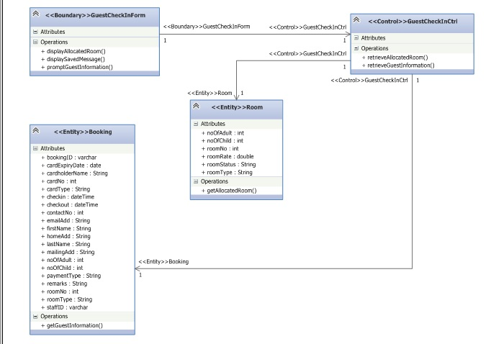

Checkout Guest
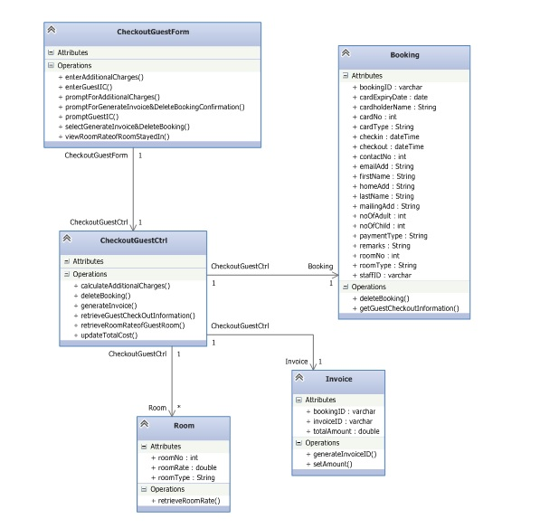
Login
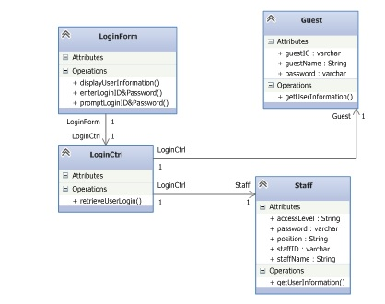
Logout
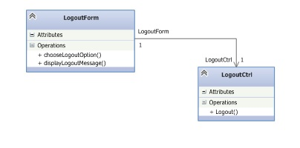
Generate Room Status Report
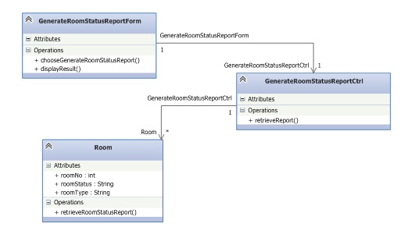
Generate All Guests in a Room Report
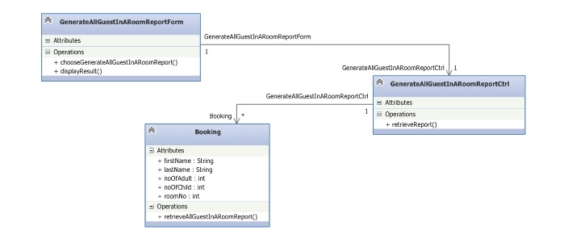

Generate All Guests in all Rooms Report
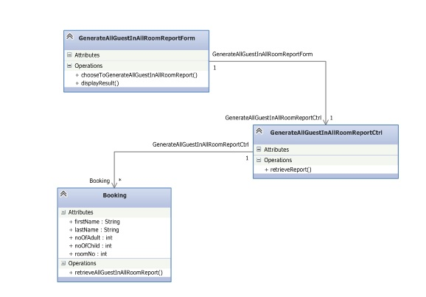

Generate Room Occupancy Report
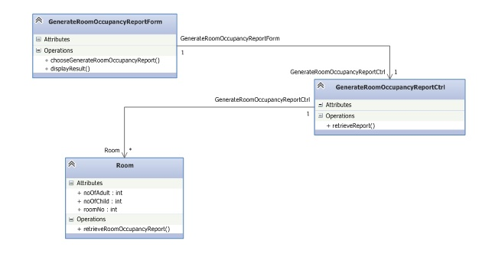
Generate Housekeeping Report
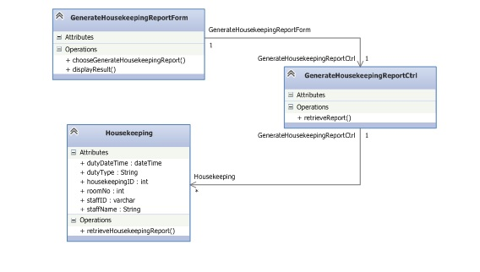
Print report
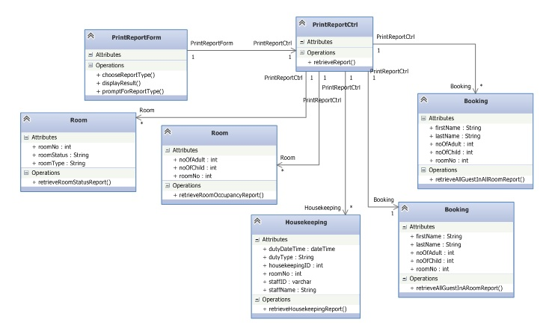
Manage Booking
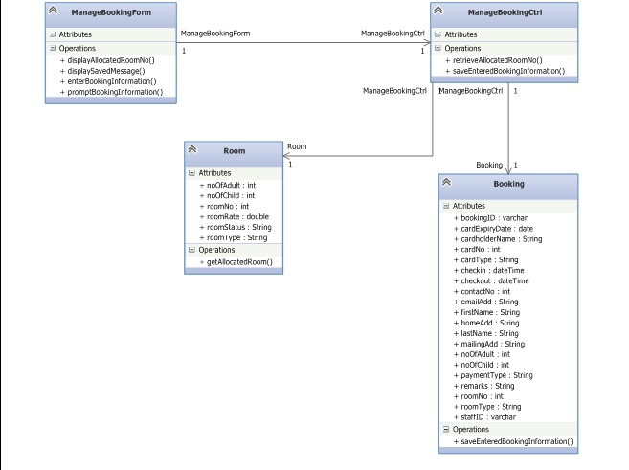
Manage guest profile
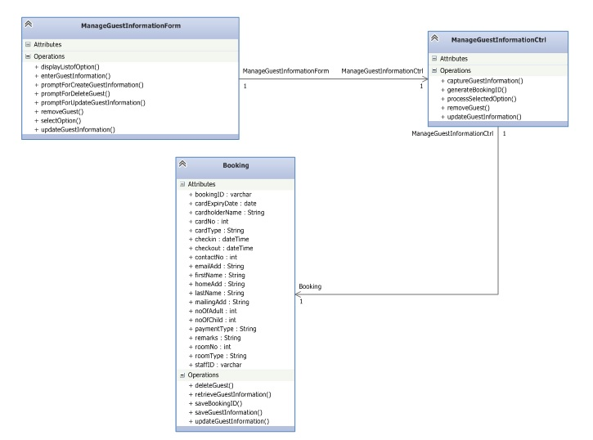

Manage staff profile
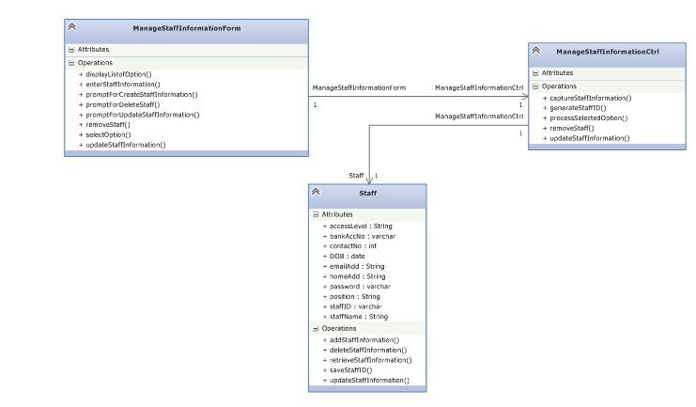

Manage staff schedule
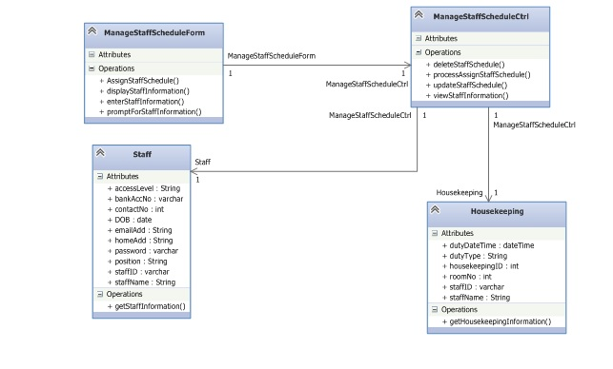

Manage user account
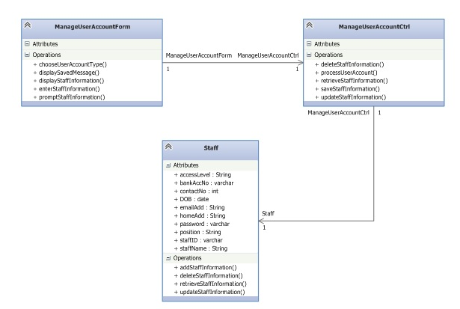

DATABASE DESIGN
Database Schema
Customer (customerid, firstname, lastname, passportno, gender, dob, email, contactno, nationality, country, checkindate, checkintime, checkoutdate, checkouttime)

Booking (bookingid, roomtype, noofroom, noofadults, noofchildren, checkindate, checkoutdate, totalamount, paymenttype, creditcardtype, creditcardno, cvc, cardholdername, cardexpirydate, remarks, pin, customerid)

Rooms (roomno, roomtype, roomrates, roomlevel, capacity, status, bookingid)

Requests (requestid, requestdate, requesttime, request, roomno)

Housekeeping (housekeepingid, staffname, typeofduty, date, time, roomno, staffid)

Staff (staffid, name, nric, dob, email, address, contactno, banktype, bankaccno, loginpassword, useraccesslevel, departmentid)

Department (departmentid, departmentname, noofstaff, departmenthead)

FAQs (email, queries)
Limitations
- Data complexity
- The database is complex, difficult and time-consuming to design, if data types are poorly chosen, it will create unnecessary complexity or limit the future development of the database
- Broken keys and records
- If different data types used to link the unique key spread across several tables are different, the database will not be able to link the information without additional rework by the report developer.
- If a table does not have a unique key, the database might also return inaccurate results.
Data Dictionary
- Customer
Description: This object contains information such as the customer’s id, full name, passport number, date of birth, email, address, phone number, gender, nationality, country which the customer live in, the actual check-in date and time of the customer and the actual check-out date and time of the customer. The customer’s id serves as a primary key in the database.
Usage: This object will represent a customer in the customer database object.
- Booking
Description: This object contains information such as the booking’s id, type of room, number of room, number of adults, number of children, check-in date, check-out date, total amount of the booking made, type of payment, type of credit card used, credit card number, security code of credit card, credit card holder’s full name, credit card’s expiry date, remarks that the customers wants the hotel staff to take note of, the pin number used for verifying the customers when they want to update the booking and the customer id. The booking’s id serves as a primary key in the database and the customer id is a foreign key which is linked to the customer id in the customer object.
Usage: This object stores all the information of a booking made by a customer in the database.
- Rooms
Description: This object contains information such as the room number, the type of room it is, the rates of the room per night, the level the room is located at, number of people that the room can host and the status of the room. The room number serves as a primary key in the database and the booking id is a foreign key which is linked to the booking id in the booking object.
Usage: This object used to represent a room in the rooms object. It stores all the information of rooms in the database.
- Requests
Description: This object contains information such as the request’s id, date and time when the request is made, what the request is about and the room number of the customer who made the request. The request’s id serves as a primary key in the database and the room number is a foreign key which is linked to the room number in the rooms object.
Usage: This object stores all the information on request made by customers. It is also used to associate with rooms object allowing staff to know which room the request is for.
- Housekeeping
Description: This object contains information such as the housekeeping’s id, the name and id of the staff assigned to this housekeeping tasks, the duties that have to be done, the date and time of the duty that have to be done by and the room number which requires housekeeping. The housekeeping’s id serves as a primary key in the database and the staff’s id and room number is a foreign key which is linked to the staff’s id in the staff object and the room number in the rooms object.
Usage: This object is used to associate staff, housekeeping and rooms object, presenting a schedule for the staff and allowing them to know what their jobs are for that day.

- Staff
Description: This object contains information such as the staff’s id, full name, nric, date of birth, email, address, phone number, bank type, bank account number, login password, user access level and department id. The staff’s id serves as a primary key in the database and the department id is a foreign key which is linked to the department id in the department object.
Usage: This object is used to associate staff and department object to know which department the staff belongs to.
- Department
Description: This object contains information such as the department’s id, name, number of staff in the department and the full name of the head of the department. The room number serves as a primary key in the database and the booking id is a foreign key which is linked to the booking id in the booking object.
Usage: This object is used to represent a department in the department database object.
- FAQs
Description: This object contains information about a customer’s enquires which includes the queries and the customer’s email address.
Usage: This object will store all the customer’s enquiries in the database.

